**Novel Machine Learning Model and Techniques for Detection of Melanoma Lesion in Images**

**S Mohan Kumar1 ,Dr T. Kumanan2**

Research Scholar, MAHER, Meenakshi University, Chennai, & Associate Professor, New Horizon College of Engineering, Bangalore, India.1

Principal, Faculty of Engineering and Technology, MAHER, Meenakshi University, Chennai, India2

**Abstract** - Skin cancer is a disease in which the diagnosis is very complex in nature.We propose a technique for detecting melanoma skin cancer which involves the segmentation of the lesion from the entire image using the otsumethod.The Boundary tracing algorithm has been used for further segmentation. After extracting the features from the lesion, classification is done using the ABCD method. The results obtained are presented in the form of statistical tables and graphs. The experimental result shows that the proposed algorithm makes good for detecting different stages of skin cancer.

***Keywords:*Melanoma, Classifier, Segmentation, Image Processing, Texture Analysis, Edge Detection, ABCD Feature Selection, CAD, Boundary Tracing Algorithms,OtsuMethod,Lesion,Classification,SkinCancer,Convolutional Neural Network,Artificial Intelligence.**

# Introduction

Skin cancer is one of the deadliest form of cancer if detection at an early stage is not done. Skin lesions may be further classified as benign melanoma and malignant melanoma which is termed as skin cancer.Our skin acts as a protective covering in our body and shields usfrom heat, sunlight, injury, and infection. Skin cancer is the most common type of cancer. Excessive exposure of our skin to the UV rays from the sun leads to skin cancer. The fair complexioned population has been more at risk to develop melanoma.Diagnosis at an early stage improves the chances of proper treatment and cure which otherwise may be fatal. Each year close to 55,000 people are diagnosedwith this type of cancer. Compared to other forms of cancer skin cancer has a high occurrencethe automatic diagnosis tool will play a vital role in fighting the disease at a very early stage. Even when an accomplished dermatologist uses the dermoscopy for diagnosis, the exactness of melanoma recognition is estimated to be about 75-84%. The computer aided diagnosisensures diagnosis accuracy as well as the speed.[17]Although Computer cannot be termed as brilliantwhen compared to humanbut may be able to obtain some information like color variation, asymmetry and texture features that may not be readily perceived by human eyes.Thegeneral approach of developing a CAD system for thediagnosis of skin cancer is to find the location of a lesion andalso to determine an estimate of the probability of a disease.

The first step in this paper was to establish a standard generalscheme of a CAD system for skin lesions.

In recent years, Image processing techniques have been used by many researchers to detect melanoma. Image processing plays a vital role for producing digital images with goodbrightness/contrast and detail is a strong requirement in medical field like vision, biomedical image analysis, cancer detection and orthopedics for the early diagnosis of melanoma[9].It is requirement for imageacquisition to be performed on digital images. In this process every pixel is assigned by a label, which will share same visual behaviors.Early stage detection of skin cancer needs computer aided detection. Generally, doctors use biopsy method forthe diagnosis of skin cancer. Biopsy is the removal or scrapping off the skin and those skin samples are undergonemany laboratory test hence it is time consuming and painful 7. There are many features or sign of skin cancer such asblue-white veil, multiple brown dots, psuedopods, radial streaming, scar-like depigmentation, globules, multiplecolors, multiple blue gray dots, pigmented network It has the difficulties of over segmentation because of the textured lesion area.[3] In this paper we propose a technique to detect skin cancer and compare with some standard reference values. It has been noted that our algorithm promises better results. Here we discuss about an approach to detect skin cancer and then as a subsequent step extract the selected features.

Discusses a cluster-outlier iterative detection algorithm, tending to detect the clusters and outliers in another perspective for noisy data sets. In this algorithm, clusters are detected and adjusted according to the intra-relationship within clusters and the inter-relationship between clusters and outliers, and vice versa. The rest of the paper is organized as follows. Section 2 reviews related work in outlier detection. Section 3 describes the proposed method to detect missing values and outlier. Experimental results and their analysis are presented in Section 4 and finally, Section 5 concludes the paper.

**2.Literature Survey**

Extensive research has been done on computer aided diagnosis of skin cancer. The input image which is a dermoscopic image is segmented using existing systems which are either manual, semi-automatic or fully automatic border detection methods. Various literature shows different border detection methods which include histogram thresholding, global thresholding on optimized color channels followed by morphological operations, hybrid thresholding. Various features based on shape, color, texture and luminescence are extracted and used in different papers. The ABCD rule of dermoscopy suggests that asymmetry is the most important among the four features of asymmetry, border irregularity, color and diameter. An extensive literature survey of the already present methods was conducted and it is noticed that different authors have suggested various ways and means to improvise the melanoma detection. Ruskar Fatima [1] proposes a multiparameter extraction and classification system which deals with extraction and classification of about 21 important parameters.P.Jayapal [22] proposes a system using hybrid spatial feature using the PNN classifier with rbf representation and radial basis type network classifier to classify skin lesion. Nidhal K. EL Abbadi [10] has suggested a CAD system for skin cancer detection inwhich initially the input images are clarified using Markov and Laplace Filter to eradicate undesired elements and finally the edge of the lesion The color image is converted to YUV color space and the U channel is selected for processing. Otsu’s thresholding method is considered to converts image to binary form. Mabrouk[9] puts forward an automated method for melanoma diagnosis. The input images are a set of dermoscopic images. The features are extracted based on grey level co-occurrence matrix. Here the classifier used is a multilayer perceptron classifier which uses 2 different techniques in training and testing process which is the automatic multilayer perceptron classifier and traditional multilayer perceptron classifier. This comes under the neural network classifiers.

Codella[11 ] has put forward a scheme that combines recent developments in deep learning with established machine learning approaches creating novel methods capable of dermascopic lesion segmentation, scrutiny of detected area and surrounding tissues for skin cancer detection. Hand coded feature extractors, sparse coding methods and SVM’s with more machine learning techniques which include deep residual networks and convolutional neural networks are combined into ensembles whose primary goal is melanoma recognition and segmentation for the given dermoscopy images. Yogendra Kumar Jain et.Al[7] has recommended a method that focuses on a skin cancer screening system that can be used even by the members who are not specifically trained for the particular process. The input to the CAD system is the images of the particular skin lesion. The edges of the input images are detected using contour tracing algorithm. The output of the edge detection becomes input to the Discrete Wavelet Transform and then the images are disintegrated and estimated coefficients are formed. The Probabilistic Network and the K-means clustering algorithm is used as classifiers. JeyaRamya [2], proposes a system in which involves the preprocessing stage, adaptive histogram equalization techniques and wiener filtering is done. An innovative method was proposed for the splitting up and classification of skin lesions. The segmentation is achieved by active contour segmentation. Features are extracted and decimated into first order, second order and higher order features. Texture features like entropy, correlation, homogeneity and energy features are extracted using GLCM and classification is done using an SVM classifier. Ebtihal Al Mansoura [21] proposesa clever CAD system for identification of skin lesions using machine learning techniques. Primarily, the images are segmented by changing color images to greyscale, applying fuzzy C means, fuzzy entropy and morphology based optical mask selection, adaptive contour method, based on optimal mask to segment skin lesions and refinement of segmentation using morphology operations.

**3.Proposed Method**

Allthe above details shows that there has been a lot of study going on in the field of skin cancer and now we propose se a novel idea for melanoma detection.In the proposal, the input for the system is the skin lesion which is suspicious to be melanoma. The images are subject to pre-processing to eject hair and noise etc.. whichcontributes in obtaining an image of very good quality. The Modified Otsu thresholding algorithm is used for image segmentation. Thevarious algorithms such as border irregularity, area, axis length etc.are used for feature classification stage and the extracted features are processed in order to classify the image as lesion, benign, suspicious or highly suspicious skin lesions. The important steps in a diagnosis of melanoma skin cancer are:

* Acquisition of lesion image.
* Preprocessing of the image to reduce noise and various irregularities.
* Segmentation of the lesion area from the outer area
* Extraction of the features from the input image.
* Classification based on the extracted features.

Feature extraction is the intent of extracting the features from the lesion image in order to characterize the melanoma.It is necessary to identify features thatare the most reproducible and diagnostically significant andformulate them into a single algorithm. But all melanomas do not have all four ABCD features. It is the combination of features (e.g., A+B, A+C, B+C, A+B+C, etc.) that render some lesions most suspicious for early melanoma. Here we present a block diagram to represent the process that is recommended in the system that we propose.The first step is the acquiring of the images by ultrasounds or any other clinical methods followed by preprocessing by which the unwanted noise like hair and glare are eliminated.Next comes the segmentation method and in this particular process the otsu method has been considered for its advantages over the other methods.

**4.Results**

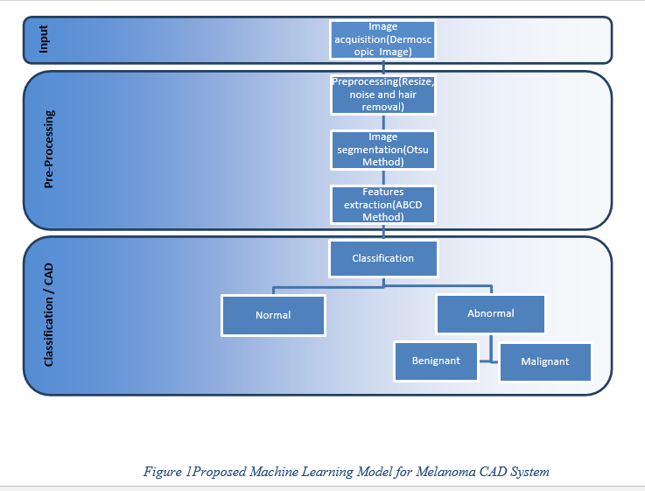

As we start the process of validation of our model, we consider 2 benign and 2 malignant images each in the following section and see their original image and preprocessed images along with their histograms:

**Benign Sample Image1**

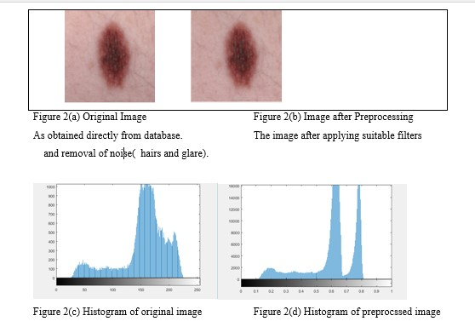

The figure 2(c) represents the histogram of figure 2(a), while figure 2(d) represents the histogram of figure 2(b).

Through the above histograms, we can clearly see the difference in the pixel density of colors between the original image and the preprocessed image.

**Benign Sample Image2:**

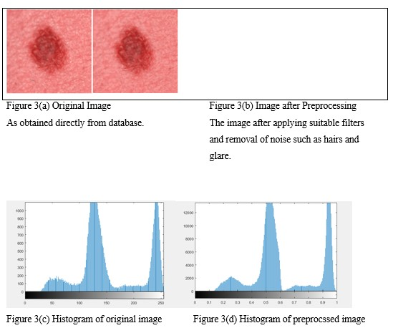

The figure 3(c) represents the histogram of figure 3(a), while figure 3(d) represents the histogram of figure 3(b).

Through the above histograms, we can clearly see the difference in the pixel density of colors between the original image and the preprocessed image.

**Melanoma Sample Image1:**

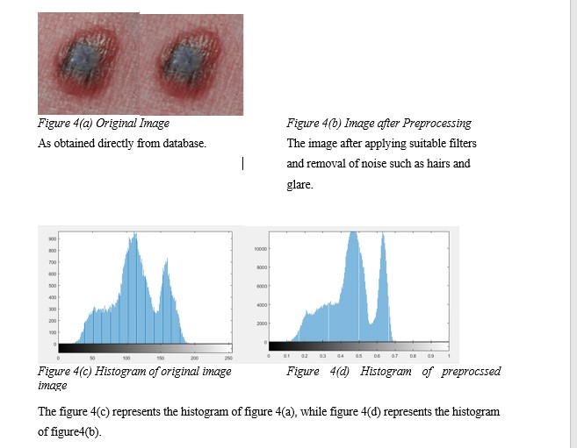

The figure 4(c) represents the histogram of figure 4(a), while figure 4(d) represents the histogram of figure4(b).

Through the above histograms, we can clearly see the difference in the pixel density of colors between the original image and the preprocessed image.

**Melanoma Sample Image2:**

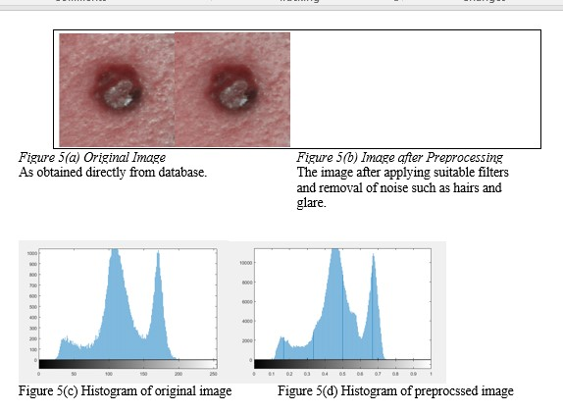

The figure 5(c) represents the histogram of figure 5(a), while figure 5(d) represents the histogram of figure 5(b).

Through the above histograms, we can clearly see the difference in the pixel density of colors between the original image and the preprocessed image.

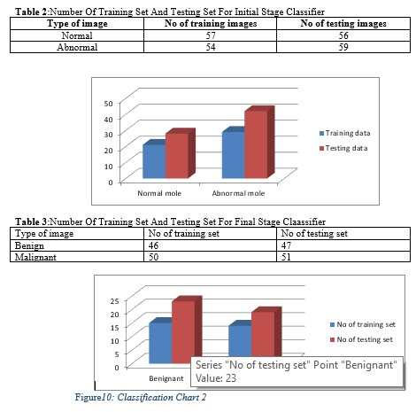

The above image shows the probable possibilities of a lesion as a normal, benign, suspicious lesion or highly suspicious of melanoma at different values of Area, Perimeter, Minor Axis Length and Major Axis length.

**5.Conclusion**

The last few decades have witnessed steady increase in the occurrence of melanoma which emphasizes the urgent need for early detection and melanoma which may lead to its cure. In the above paper, we have presented a skin cancer detection and feature extraction system which uses Modified Otsu thresholding and boundary tracing algorithm. The experimental result displays the best performance of detecting acancerous image along with identification of the stages such as benign, suspicious, highly suspicious or just a lesion. This approach gives as better results compared to the other methods used.

**6.References:**

1. Ruksar Fatima, Mohammed Zafar Ali Khan , A. Govardhanand Kashyap D Dhruve,”Computer Aided Multi-Parameter Extraction System to Aid Early Detection of Skin Cancer Melanoma”, IJCSNS International Journal of Computer Science and Network Security, VOL.12 No.10,October 2012,pp 74-86

2. V. Jeya Ramya, J. Navarajan, R. Prathipa& L. Ashok Kumar,” Detection Of Melanoma Skin Cancer Using Digital camera Images”, ARPN Journal of Engineering and Applied Sciences, L. 10, NO. 7, APRIL 2015,pp 3082-3085.

3. Dr. S. Mohan Kumar&Dr.T.Kumanan “Study on skin Lesion Classifications system and Dermoscopic Feature Analysis for Melanoma”, International journal of Creative Research Thoughts (IJCRT)IJCRT1802680, Volume 6, issue-1 , Page No . 1863 – 1873 , March 2018.

4. T. Saida, A. Miyazaki, S. Oguchi, Y. Ishihara, Y. Yamazaki & S. Murase . “Significance of dermoscopic patterns in detecting malignant melanoma on acral volar skin”. Arch Dermatol 140 (2004) 1233-1238.

5. S. E. Umbaugh, R.H. Moss, W.V. Stoecker, G.A. Hance,“Automatic color segmentation algorithms with applicationto skin tumor feature identification”, IEEE Eng Med BioVol. 12, 1993, pp.75-82.

6. Dr. S. Mohan Kumar&Anisha Rebinth,“Automated detection ofRetinal Defects using imagemining-A review”,European Journal of Biomedical and Pharmatical SciencesEuropean Journal of Biomedical and Pharmatical sciences ISSN : 2349 – 8870, Volume 5 , Issue : 01, 189 – 194 year : 2018.

7. Yogendra Kumar Jain, “Comparison between Different Classification Methods with Application to Skin Cancer”, International Journal of Computer Applications (0975 – 8887) Volume 53– No.11, September 2012 .

8. G. Argenziano, H.P. Soyer, S. Chimenti, R. Talamini, R. Corona, F. Sera et al. “Dermoscopy of pigmented skin lesions: results of a consensus meeting via the Internet”. J Am Acad Dermatol 48 (2003) 679-93.

9. Dr. S. Mohan Kumar&Dr.T.Kumanan “Skin Lesion Classification System and Dermoscopic Features Analysis for Melanoma recognition and Prevention”, International Journal of Emerging Technology and Advanced Engineering ,Volume 7 , Issue 8, August 2017 , Pp no: 351 – 357.

10. Nidhal K. EL Abbadi and Zahraa Faisal, Detection and Analysis of Skin Cancer from Skin Lesions, International Journal of Applied Engineering Research ISSN 0973-4562 Volume 12, Number 19 (2017) pp. 9046-905.

11. Codella, Noel & Nguyen, Quoc-Bao &Pankanti, S & Gutman, David &Helba, Brian & Halpern, Allan & R. Smith, John. (2017). “Deep Learning Ensembles for Melanoma Recognition in Dermoscopy Images”. Ibm Journal of Research and Development 61. . 10.1147/JRD.2017.2708299.

12. Shreya R, SriLakshmiChandru,VivekKumar,ShwethaM,Dr. S. Mohan Kumar,J. Karthikayini,”Surveys on Detection ofMelanoma through imageprocessing Techniques”,International Journal for Researchin applied science and Engineering Technology,volume 6, Issue III, March 2018 inIJRASET, DOI: 10.22214), , ISSN : 2321– 9653, Impact Factor : 6.887pp. no.: 1699-1704.

13. M. S. Mabrouk, M. A. Sheha, and A. Sharawy, “Automatic detection of melanoma skin cancer using texture analysis,” International Journal of Computer Applications, vol. 42, no. 20, pp. 22–26, 2012.

14. Mariam A. Sheha, Automatic Detection of Melanoma Skin Cancer using Texture Analysis, International Journal of Computer Applications, Vol 42, No. 20, 2012.

15. Dr. S. Mohan Kumar&Dr.T.Kumanan “Analysis on skin Lesion classification systems and Dermoscopic Feature Analysis for Melanoma “,International Journal for Research in Applied Science and Engineering Technology (IJRASET)ISSN:2321-9653 ,Volume 6, Issue - 3, March – 2018 in (DOI : 10.22214),pp. no.:1971-78.

16. G. Argenziano, G. Fabbrocini, P. Carli, V. De Giorgi, E. Sammarco, andM. Delfino. “Epiluminescence microscopy for the diagnosis of doubtfulmelanocytic skin lesions. comparison of the abcd rule of dermatoscopy and a new 7-point checklist based on pattern analysis.” Arch. Dermatol.,134(12):1563–1570, 1998.

17. Dr.S MohanKumar&R.Jaya,”A Survey On Medical DataMining – Health Care RelatedResearch And Challenges,International Journalof Current Research,Volume 8, Issue 01,Page Numbers;25170-25173.

18. Korotkov, K. & Garcia, R. (2012),“Computerized Analysis of Pigmented Skin Lesions: A review”” Artificial Intelligence in Medicine, Vol. 56, pp. 69-90.

19. D. Altamura, E. Altobelli, T. Micantonio, D. Piccolo, M.C. Fargnoli& K. Peris. “Dermoscopic patterns of acral melanocytic nevi and melanomas in a white population in Central Italy”. Arch Dermatol 142 (2006) 1123-1128.

20. Yu, L., Chen, H., Dou, Q., Qin, J., Heng, P.A. “Automated melanoma recognition in dermoscopy images via very deep residual networks”. IEEE Trans. Med. Imaging. 2017;36:994–1004.

21. EbtihalAlMansour, M. Arfan Jaffar& Shahad AlMansour “Fuzzy Contour based Automatic Segmentation of Skin Lesions in Dermoscopic Images”, IJCSNS International Journal of Computer Science and Network Security, VOL.17 No.1, January 2017,pp177-186.

22. P.Jayapal ,R.Manikandan , M.Ramanan , R.S. Shiyam Sundar1 & T.S. UdhayaSuriya,” Skin Lesion Classification Using Hybrid Spatial Features and Radial Basis network”, International Journal of Innovative Research in Science,Engineering and Technology,pp -10014-10021.

23. Dr.MohanKumar S&Dr.Balakrishnan,”Classification Of Breast MassClassification – CAD SystemWith Performance Evaluation”,International Journal Of Engineering And Computer Science,Vol 4,Issue9, September 2015.

24. Shreya R, SriLakshmi Chandru,VivekKumar,ShwethaM,Dr. S. Mohan Kumar,DrJitendranathMungara, J.Karthikayini,”Design and implementation ofCNN for detecting Melanomathrough image processing”,International Journal for Researchin Applied Science and EngineeringTechnology,Volume 6, Issue - 3, March –2018 pp. No.: 2249-2253.